**Simple DevOps Project - 4**

In this project, we will be see how to *use Git, Jenkins, Ansible, DockerHub, Docker to DEPLOY on a docker container.,*

*Follow this project in [Youtube](https://youtu.be/MJ74RcL6jv8)*

[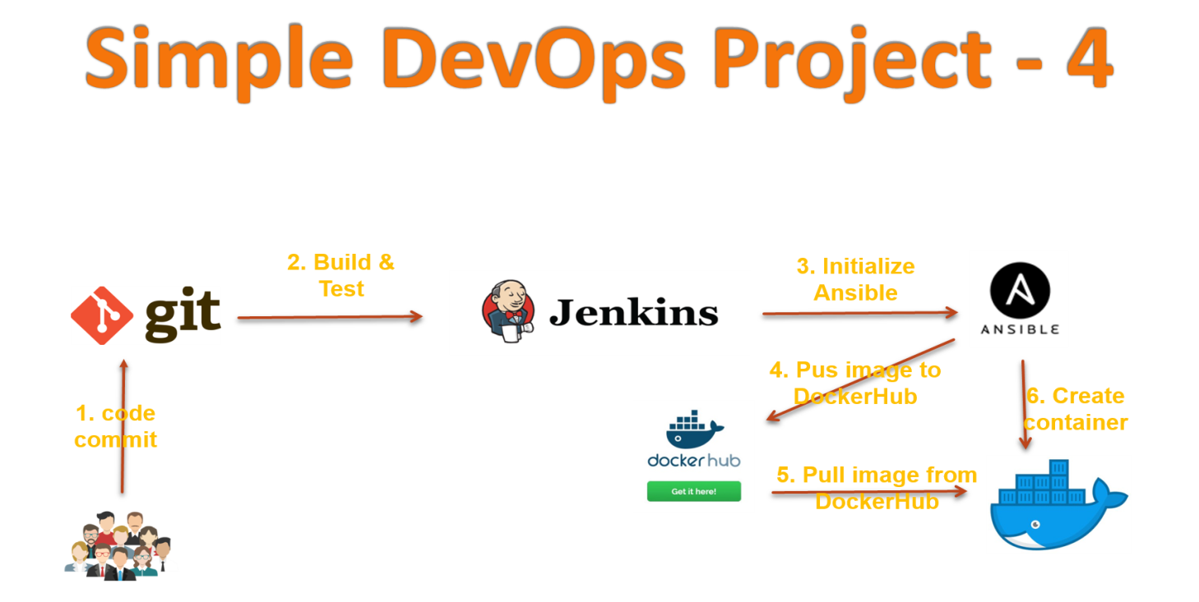](https://github.com/ValaxyTech/DevOpsDemos/blob/master/SimpeDevOpsProjects/images/Project-4.png)

**PreRequisites**

1. Jenkins - Get help [here](https://www.youtube.com/watch?v=M32O4Yv0ANc)
2. Ansible - Get help [here](https://www.youtube.com/watch?v=79xFyOc_eEY)
3. Setup ansible client and install docker. [here](https://www.youtube.com/watch?v=nMLQgXf8tZ0)
4. Docker Hub account

**Previous DevOps projects:**

1. Simple DevOps project-1 [here](https://www.youtube.com/watch?v=Z9G5stlXoyg)
2. Simple DevOps project-2 [here](https://www.youtube.com/watch?v=nE4b9mW2ym0)
3. Simple DevOps project-3 [here](https://www.youtube.com/watch?v=nMLQgXf8tZ0)

In *part-01* we create Docker image on ansible server through Jenkins job and pushed it onto DockerHub.

**Part-01 : Create an docker image**

1. Login to Jenkins console
2. Create *Jenkins job*, Fill the following details,
   * *Source Code Management:*
     + Repository : https://github.com/ValaxyTech/hello-world.git
     + Branches to build : */master
   * *Build:*
     + Root POM:pom.xml
     + Goals and options : clean install package
   * *Post Steps*
     + *Send files or execute commands over SSH*
       - Name: ansible_server
       - Source files : webapp/target/*.war
       - Remove prefix : webapp/target
       - Remote directory : //opt//docker
     + *Send files or execute commands over SSH*
       - Name: ansible_server
       - Source files : Dockerfile
       - Remote directory : //opt//docker
       - Exec Command:
         * cd /opt/docker
         * docker build -t valaxy_demo .
         * docker tag valaxy_demo valaxy/valaxy_demo
         * docker push valaxy/valaxy_demo
         * docker rmi valaxy_demo valaxy/valaxy_demo
3. Login to Docker host and check images and containers. (no images and containers)
4. login to docker hub and check. shouldn't find images with for valaxy_demo
5. Execute Jenkins job
6. check images in Docker hub. Now you could able to see new images pushed to Valaxy Docker_Hub

**Troubleshooting:**

1. Docker should be installed on ansible server
2. Should login to "docker hub" on ansible server
3. Docker admin user should be part of docker group

In *Part-02* we create *create_docker_container.yml* playbook. this get intiated by jenkins job, run by ansible and exected on dokcer_host

**Part-02 : Deploy Containers**

1. Write a yml file to create a container (file name : create_docker_container.yml)
2. ---
3. - hosts: web-servers
4. become: true
5. tasks:
6. - name: stop previous version docker
7. shell: docker stop valaxy_demo
8. - name: remove stopped container
9. shell: docker rm -f valaxy_demo
10. - name: remove docker images
11. shell: docker image rm -f valaxy/valaxy_demo
13. - name: create docker image
14. shell: docker run -d --name valaxy_demo -p 8090:8080 valaxy/valaxy_demo
15. Add this script to Jenkins job.
    * Chose *"configure"* to modify your jenkins job.
      + *Under post build actions*
        - Send files or execute commands over SSH
          * Exec Command:
        - cd /opt/playbooks

ansible-playbook create_docker_container.yml

1. Execute Jenkins job.
2. You could see a new container on your docker host. can able access it from browser on port 8090

Troubleshooting: Makesure you have opened required ports on AWS Security group for this server.

In *Part-03* we try to improvise to store docker images previous versions

**Part-03 : Deploy with Version Control Containers**

So for we used latest docker image to build a container, but what happens if latest version is not working?  
One easiest solution is, maintaining version for each build. This can be achieved by using environment variables.

here we use 2 variables

* BUILD_ID - The current build id
* JOB_NAME - Name of the project of this build. This is the name you gave your job when you first set it up.

for more info Please refer [this URL](https://wiki.jenkins.io/display/JENKINS/Building+a+software+project)

Lets modify jenkins job which was created in *Part-01* as below.

1. Create Jenkins job
   * *Source Code Management:*
     + Repository : https://github.com/ValaxyTech/hello-world.git
     + Branches to build : */master
   * *Build:*
     + Root POM:pom.xml
     + Goals and options : clean install package
   * *Send files or execute commands over SSH*
     + Name: ansible_server
     + Source files : webapp/target/*.war
     + Remove prefix : webapp/target
     + Remote directory : //opt//docker
   * *Send files or execute commands over SSH*
     + Name: ansible_server
     + Source files : Dockerfile
     + Remote directory : //opt//docker
       - cd /opt/docker
       - docker build -t $JOB_NAME:v1.$BUILD_ID .
       - docker tag $JOB_NAME:v1.$BUILD_ID valaxy/$JOB_NAME:v1.$BUILD_ID
       - docker tag $JOB_NAME:v1.$BUILD_ID valaxy/$JOB_NAME:latest
       - docker push valaxy/$JOB_NAME:v1.$BUILD_ID
       - docker push valaxy/$JOB_NAME:latest
       - docker rmi $JOB_NAME:v1.$BUILD_ID valaxy/$JOB_NAME:v1.$BUILD_ID
       - valaxy/$JOB_NAME:latest

**References**

[1] - [Jenkins Docs - Building Software Projects](https://wiki.jenkins.io/display/JENKINS/Building+a+software+project)